Source: <https://www.cms.gov/Outreach-and-Education/Medicare-Learning-Network-MLN/MLNProducts/downloads/Hospital_VBPurchasing_Fact_Sheet_ICN907664.pdf>

* The aim of value based purchasing is meant to reward hospitals with incentive payments for the quality of care provided
* CMS pays the hospital based on
  + How well they performed on scores compared to other hospitals
  + How much they improved on their performance
* Weightings for FY’18 for VBP:
  + Safety: 25%
  + Clinical Care: 25%
  + Efficiency and Cost Reductions: 25%
  + Patient and Caregiver-centered experience of care/ care coordination (person and community engagement): 25%
* 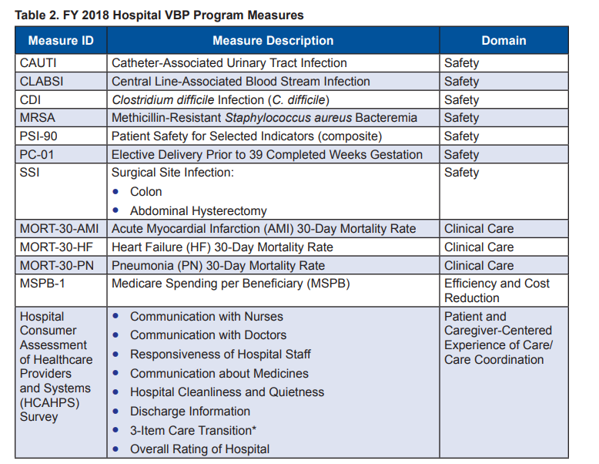
* So Medicare spending per beneficiary is 25% of the VBP measures – falls under the efficiency and cost reduction category
* Achievement points are awarded based on how well your hospital does versus other hospitals
* Improvement points are awarded passed on how a hospital does versus its own scores the previous period (performance period vs baseline period)
* Performance and improvement periods for FY’18:
* 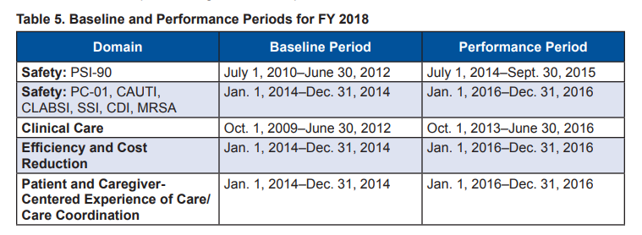
* As you can see these periods are a bit dated so this will give you information on how well the hospital is doing in the past
* VBP adjustments are made to the base operating Medicare Severity Diagnosis Related Group (MS-DRG) payments for each discharge on a per-claim basis
* Hospital MS-DRG payments are reduced by 2% initially and based on your total scores you can get a portion or all of that back

Source: <https://www.healthcatalyst.com/understand-value-based-reimbursement>

* In this new value based environment/ value-based reimbursement structure hospital dollars are now at risk unless you have a high performing hospital
  + To becoming high performing you need to have success with risk-adjusted mortality, risk-adjusted readmission rates, and low cost structure \
* There are four programs that CMS has to improve quality:
  + The Hospital Acquired Condition Reduction Program: 1% deduction in Medicare inpatient payments for the highest 25% rate of conditions
  + Hospital Value-Based Purchasing Program: There have been several studies and articles showing that this program has not shown significant changes
  + Hospital Readmission Reduction Program
  + Hospital Inpatient Quality Report (IQR)

Other Source: The MSBP Measure Information Form in this link: https://www.qualitynet.org/dcs/ContentServer?c=Page&pagename=QnetPublic%2FPage%2FQnetTier4&cid=1228772057350

* THE MSRB measure is the ratio of price-standardized, risk adjusted MSPB amount for each hospital divided by the episode-weighted median MSPB amount across all hospitals
* Price Standardization:
  + The aim is to focus on differences in beneficiary resource use that hospital can influence through appropriate practices and care coordination
  + Thus the MSPB measure aims to remove sources of variation that are not directly related to decisions to utilize care such as regional price differences
  + Basically the price standardization aims to exclude geographic payment rate differences (ex: Hospital wage index, geographic practice cost index )
  + Eliminates payments to hospitals for graduate indirect medical education (IME), DSH, and payments associated with incentive payment programs
  + **Preserves** differences that result from healthcare delivery choices such as:
    - Setting where the service is provided (physician office vs outpatient hospital)
    - Type of healthcare provider who provides the service (physician vs nurse practitioner)
    - Number of service provided in the same encounter
* Risk Adjustment:
  + Adjusts the MSPB for age and severity of illness
  + Does not adjust for sex or race
  + Severity of illness is measured using 79 hierarchical condition category (HCC) indicators
  + Adjusts for comorbidities
* The whole point of all these adjustments is to get an idea of the per-episode spending level for a hospital assuming its composition of episodes matches that of the national average
* The measure is not used for hospitals with less than 25 hospitals to reduce the likelihood of excessive skew
* f